**FUR-LICENSE**

**Group Members**

Alasan, Julianna Joyce

Baquero, Riza Mae

Salvaleon, Jed

Dagasuhan, Jedia Nicole

Agusan, Joshua

**An Object Oriented Programming Project**

Department of Information Technology

College of Engineering and Technology

University of Science and Technology of Southern Philippines – Claveria Campus

Claveria Misamis Oriental, 9004 Philippines

December 10, 2024

**I. Background of the Study**

The FURLICENSE system is designed to address the challenges faced by pet owners in obtaining licenses for their pets. Traditionally, acquiring a pet license involves multiple visits to the pet licensing office, requiring individuals to fill out forms, wait for processing, and return to claim their license. This process can be time-consuming and inconvenient, particularly for those with busy schedules or limited mobility. FURLICENSE offers a modern solution that streamlines this procedure, allowing users to complete the application online and simply wait for their license to be ready.

This system provides an easy-to-use platform that eliminates the need for repeated trips to the licensing office. Users can fill out all necessary information from the comfort of their homes, ensuring a smoother and more efficient application process. Once the license is prepared, users only need to present a screenshot of their license information from their account, two 2x2 photos of their pet, and their valid ID to claim their license. By adopting this digital approach, FURLICENSE reduces the physical and logistical burdens often associated with traditional methods.

The primary aim of FURLICENSE is to minimize waiting times and enhance the overall experience for pet owners seeking licenses. By enabling a remote application process, this system reduces crowding and delays at licensing offices, allowing staff to focus on processing applications more efficiently. Furthermore, it ensures that pet owners spend less time navigating bureaucratic procedures, making the licensing process less daunting and more accessible.

In addition to its practical benefits, the FURLICENSE system represents a step toward modernizing public services for pet owners. It highlights the importance of leveraging technology to create user-friendly solutions that address common challenges. This project not only promotes efficiency but also emphasizes convenience, empowering users to take control of their pet licensing needs without unnecessary hassle.

**II. Objectives**

1. **Streamline the Pet Licensing Process**  
   To simplify the pet licensing application process by allowing users to submit their information and requirements online, eliminating the need for multiple visits to the licensing office.
2. **Reduce Waiting Time for Pet Owners**  
   To minimize the time spent by pet owners in obtaining their licenses by providing a system that automates application, processing, and status tracking.
3. **Enhance Accessibility and Convenience**  
   To offer a user-friendly platform that makes the licensing process more accessible, particularly for individuals with limited mobility, busy schedules, or those who prefer online solutions over in-person interactions.

**III. Scope and Delimitation of the Study**

The scope of FURLICENSE encompasses features for both customers and administrators, focusing on streamlining pet license registration and renewal processes. This system is exclusive for cats and dogs only. Customers can register multiple accounts, submit applications for new registrations and renewals, and view both their personal and pet information. On the administrator side, the system allows viewing all registered users, managing requests, and monitoring approved and declined submissions. Administrators are also responsible for setting license validity within the system, with the ability to forcefully invalidate licenses if necessary.

However, the system has several limitations. Customers cannot update their personal or pet information once submitted. They also cannot upload or send pictures and cannot provide feedback, as the system is designed solely for license registration and renewal. It only supports renewals for licenses initially registered through the platform, excluding licenses from other sources, and does not offer other services available at the licensing office. Customers will not be notified if their license request is declined or approved; however, if their request is approved, their license information will be displayed in the Active Licenses section of the system. Administrators cannot modify user or license information, and the system lacks support for feedback, limiting communication beyond license-related tasks. Despite these limitations, FURLICENSE provides an efficient platform for managing pet licensing processes.

**IV. Flowchart**

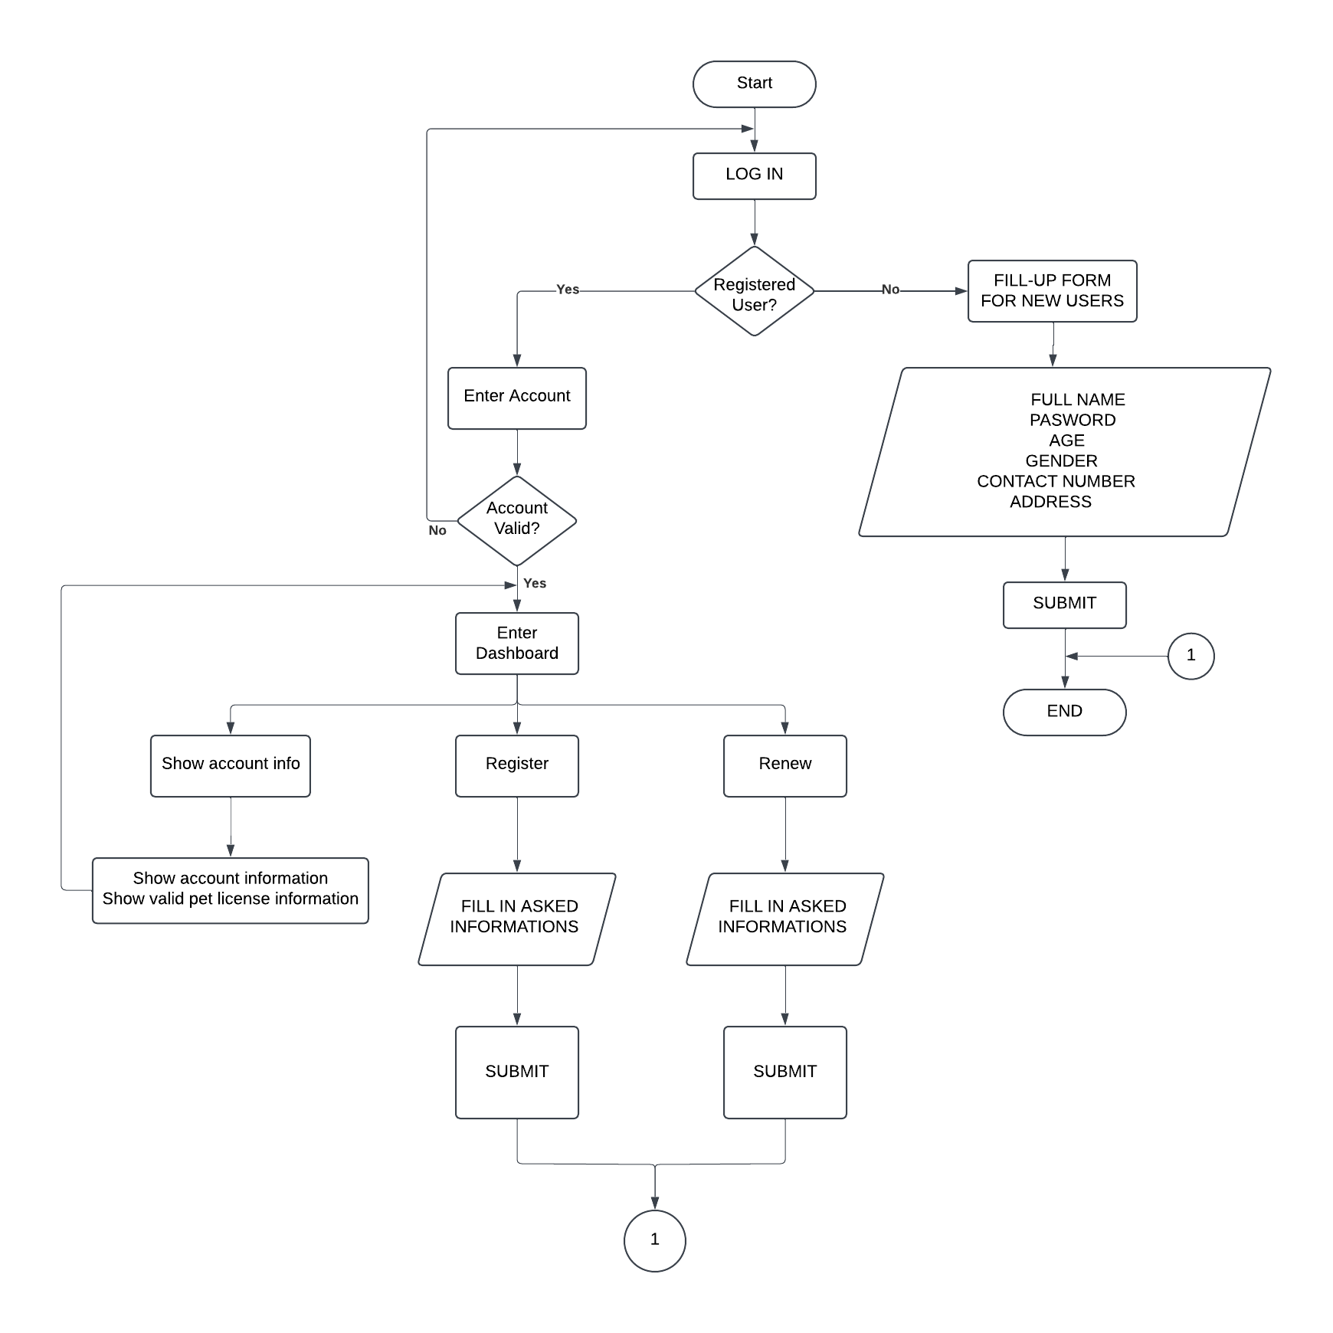**CUSTOMER SIDE SYSTEM FLOW CHART**

The flowchart represents the **FURLICENSE system's customer-side application** process, outlining the steps for account management, registration, and renewal of pet licenses. The process starts with the customer logging into the system, where it checks if the user is already registered. If the user is not registered, they are prompted to fill out a form with details such as their name, password, age, gender, contact number, and address, which is then submitted to complete their registration. For registered users, the system validates their account credentials. If the account is valid, the user gains access to the dashboard, where they can choose from three options: viewing their account and valid pet license information, registering a new pet license by filling out the required details, or renewing an existing license by providing the necessary information. After completing these tasks, users can submit the forms to finalize their requests, streamlining the licensing process for pet owners.

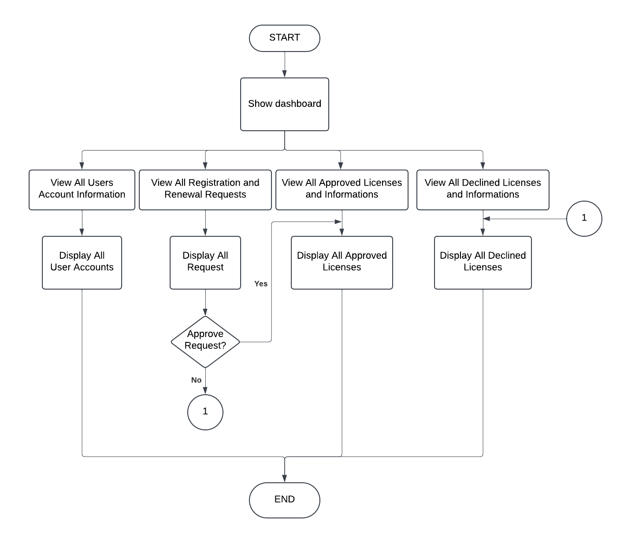**ADMIN SIDE SYSTEM FLOW CHART**

The flowchart illustrates the **FURLICENSE system's admin-side operations**, detailing the processes available to administrators for managing user accounts and license-related tasks. The process begins with the admin accessing the dashboard, where they can choose from several options. First, they can view all user account information, which displays a list of all registered users. Second, they can review all registration and renewal requests, allowing them to approve or decline these requests based on the provided details. Approved requests are categorized and displayed as valid licenses, while declined requests are also documented and displayed separately. Additionally, the admin can view all previously approved licenses and their associated information, as well as all declined licenses. This structure enables administrators to efficiently monitor and manage the licensing processes, ensuring accurate and streamlined operations within the system.

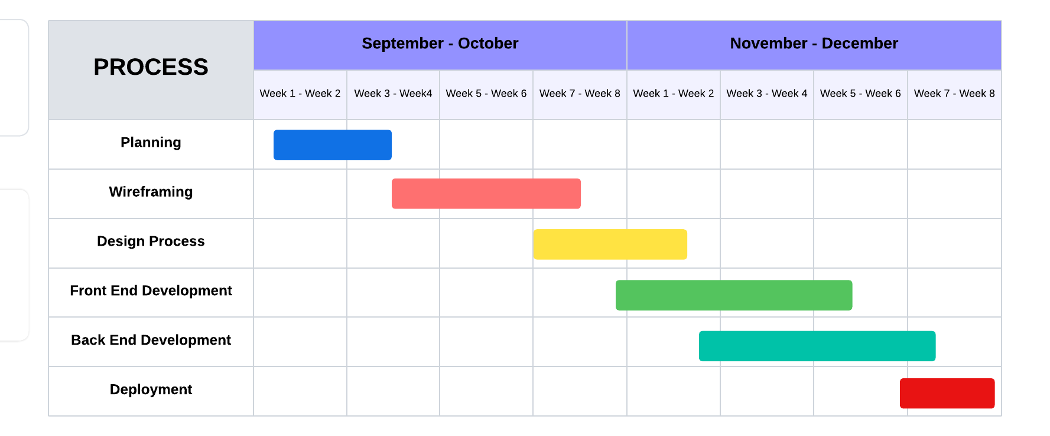**V. Gantt Chart**

The Gantt chart presented outlines the timeline for the development of the **FURLICENSE App**, detailing the various stages of the project from **September to December**. The chart divides the project into several phases, each with specific tasks and timelines.

The **Planning** phase occurs during the first two weeks of September, where the project’s objectives, requirements, and roadmap are established. This initial step sets the foundation for the app's development by defining its scope and features. Following this, the **Wireframing** phase takes place in weeks 3 and 4 of September. During this stage, the structure and layout of the app are designed, creating a blueprint for the user interface and the primary features.

In the subsequent **Design Process** (weeks 5-6 of September), the focus shifts to finalizing the app's visual elements, ensuring that the interface is both functional and visually appealing. This is followed by the **Front-End Development** phase, which spans from week 7 of October to week 2 of November. In this phase, the design is transformed into a working user interface, with interactive elements and the front-end logic being implemented.

The **Back-End Development** phase, taking place from weeks 3 to 5 of November, is centered on the creation of the server-side logic and database integration. This critical step ensures that the app functions smoothly and that data is securely stored and retrieved. Finally, the project concludes with the **Deployment** phase, which occurs from week 6 to week 8 of December. During this phase, the app undergoes final testing to ensure it meets the necessary quality standards before it is prepared for potential future release.

This Gantt chart provides a clear overview of the FURLICENSE App development timeline, illustrating how each phase builds upon the previous one, ensuring that the app is thoroughly tested and ready for evaluation at the conclusion of the project.

**VI. System Design**

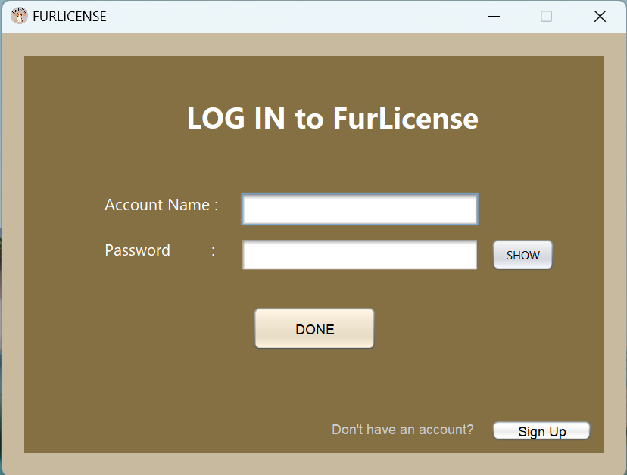

This is the **Login Interface** of the **FurLicense System – Customer side**, designed to provide a secure and user-friendly gateway for accessing the application. It features input fields for the user's account and password, with a "Show" button to toggle password visibility, reducing input errors. The "DONE" button submits credentials for validation, while the "Sign Up" button redirects new users to the registration page, ensuring seamless onboarding. Instructional text, such as "Don't have an account?" further guides users effectively. The warm brown and beige color palette reflects a professional and approachable aesthetic, while the clean layout ensures accessibility for users of all technical levels. This interface plays a vital role in maintaining security and usability, aligning with the system’s goal of streamlining pet licensing processes.

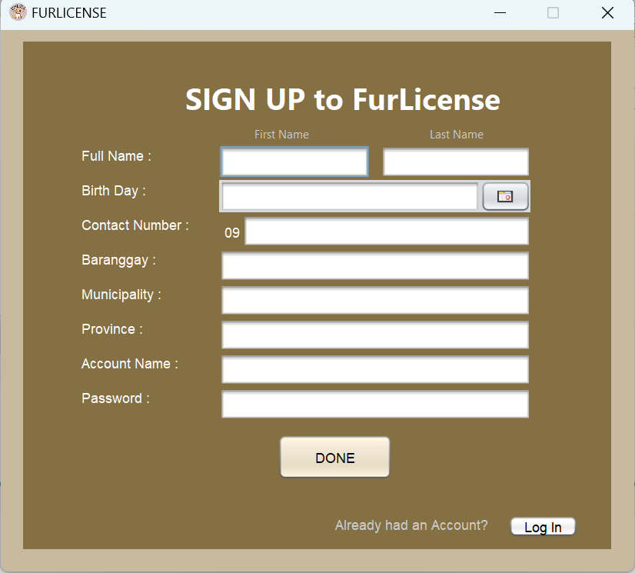

This is the **Sign-Up Interface** of the **FurLicense System – Customer Side**, designed to facilitate new user registration. The form requires users to input essential details, including their full name (split into first and last name), age, contact number, barangay, municipality, province, desired account name, and password. A prominent "DONE" button is provided for form submission, while a "Log In" link at the bottom redirects users to the login page if they already have an account. The organized layout ensures ease of navigation, and the consistent brown and beige color scheme maintains the system's professional yet approachable aesthetic. This interface plays a crucial role in collecting user information securely and efficiently, aligning with the system’s purpose of providing a streamlined pet license registration and renewal process.

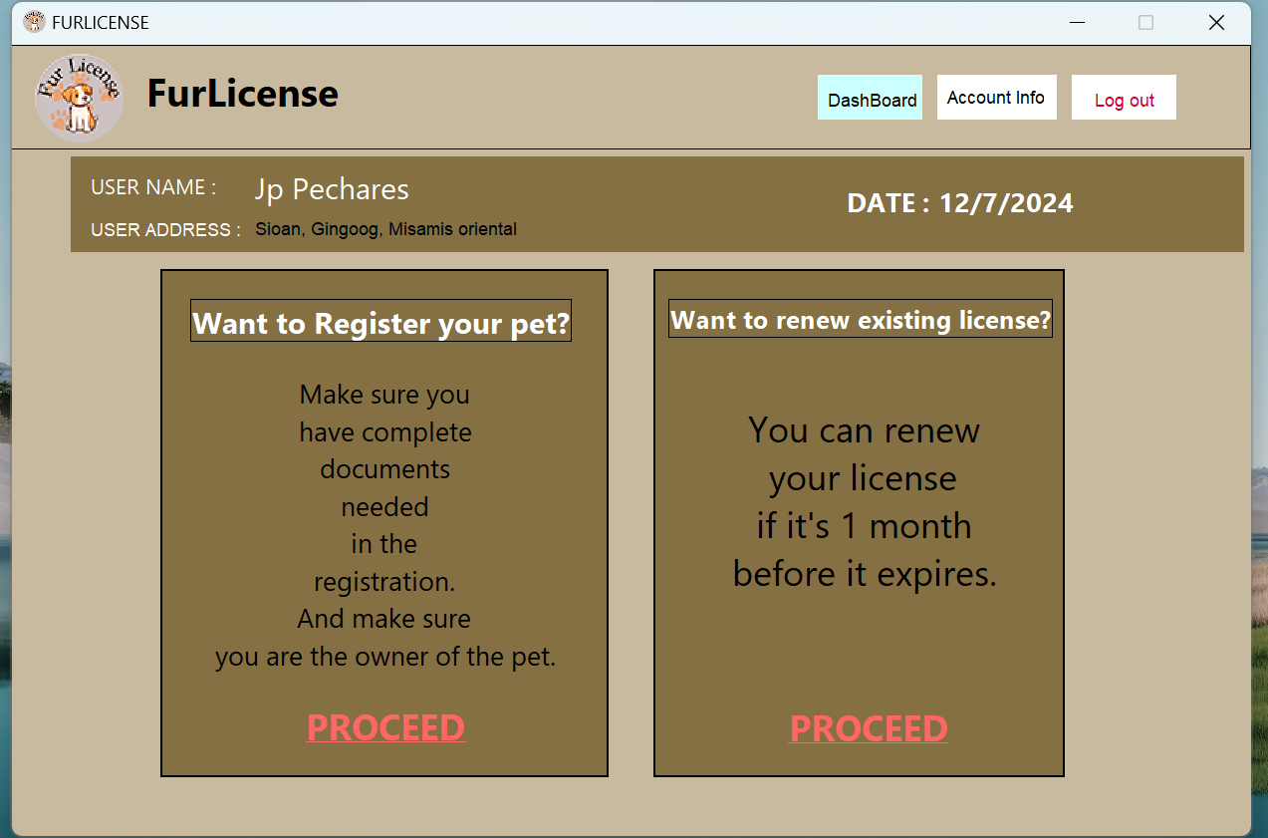

This is the **Dashboard Interface** of the **FurLicense System - Customer Side**, serving as the central hub for users to manage their pet licensing needs. At the top, it prominently displays the **user's name and address** along with the current date, ensuring personalization and context. The interface is divided into two main options: **Register Your Pet** and **Renew Existing License**.

The **Register Your Pet** section provides guidance for new registrations, highlighting the need for complete documentation and proof of pet ownership. The **Renew Existing License** section facilitates license renewal, provided it is initiated within one month before expiration. Each section includes a clearly labeled "PROCEED" button for user interaction.

Essential navigation options, such as **Dashboard**, **Account Info**, and **Log Out**, are positioned at the top-right corner for ease of access. The warm color scheme enhances usability, aligning with the system's goal of providing a professional and straightforward user experience.

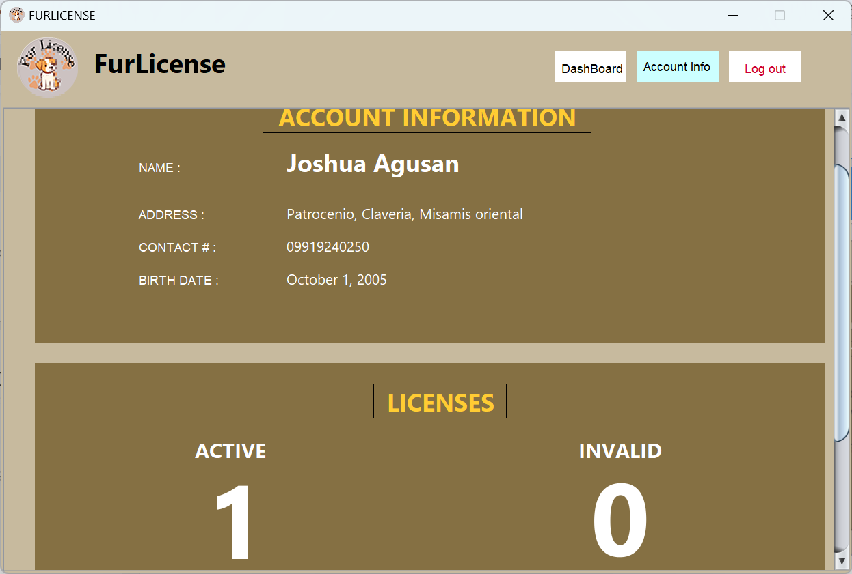

This section serves as the **Dashboard Interface of the FurLicense System – Customer Side**. It represents the second part of the dashboard, where users can **view their personal information and pet details** in a clear and organized manner. This interface provides a comprehensive display of user-specific details, such as name, contact information, and address. Additionally, it showcases key pet-related information, including the pet's name, breed, age, vaccination status, and licensing information. The system is designed to ensure that users can easily access and review this information, but they do not have the ability to edit or modify any of the displayed details.

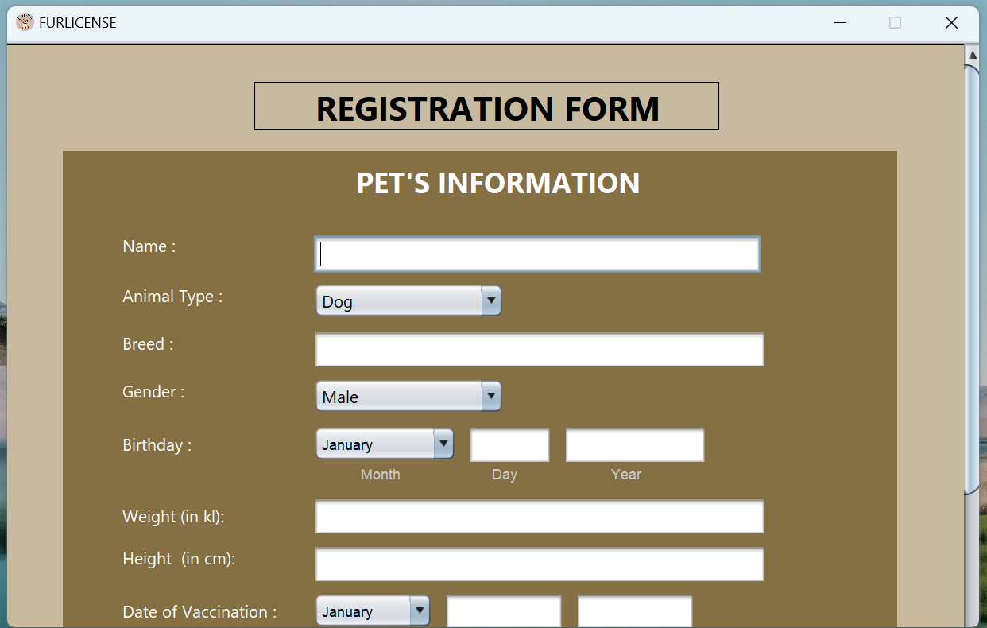

This section serves as the **Registration Interface of the FurLicense System – Customer Side**. In this part of the system, users are required to provide all the necessary information related to their pet for the registration process. This includes key details such as the pet's name, breed, age, vaccination records, and any other essential information for licensing. Once the user has completed the form and submitted the registration request, the system processes the information and automatically redirects the user back to the main dashboard. While users can view their personal and pet information on the dashboard, they cannot check the status of their pet's license during the review process. However, once the license is approved, they will be able to view their license information directly through the system.

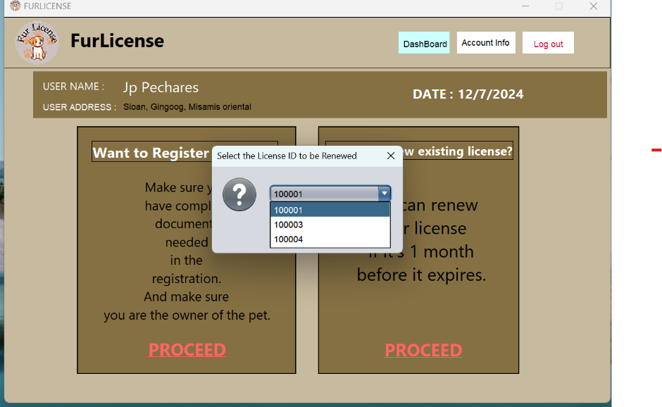

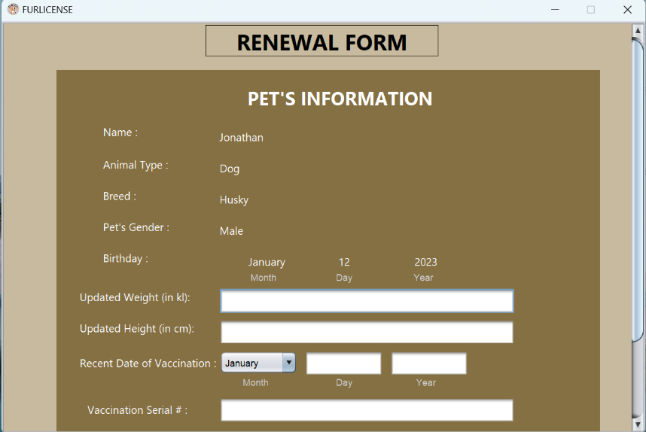

This section serves as the **Renewal Interface of the FurLicense System – Customer Side**. The renewal process is divided into two main interfaces. First, when the user taps the **Proceed** button in the renewal section, they are prompted to select the registered license they wish to renew from a list of their active licenses. Once a license is selected, the user is directed to the second part of the process, where they are required to provide updated information about their pet. This includes the pet's **height, weight, most recent anti-rabies vaccination date, and vaccination ID number**. After entering the necessary details, the user submits the renewal request, and the system automatically redirects them back to the main dashboard.

Similar to the registration process, users will not be notified if their renewal request is declined. However, if the request is approved, the updated license information will be displayed in the **Active Licenses** section of the system. This process ensures a simple, step-by-step approach for users to update essential pet information as part of the renewal procedure.

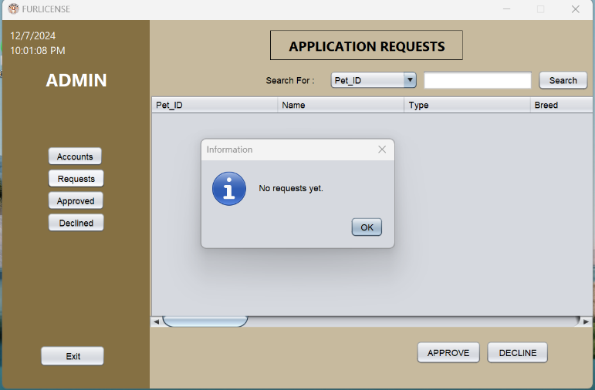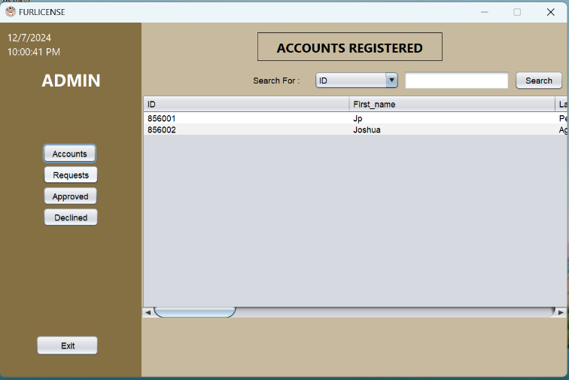

This section represents the **Main Dashboard Interface of the FurLicense System – Admin Side**. The dashboard is divided into four key interfaces, each serving a specific administrative function.

1. **User Accounts Interface**: This is the first interface displayed when accessing the system. It provides a complete list of all user accounts registered in the system, allowing administrators to view essential user information.
2. **Requests Interface**: The second interface displays all pending license requests submitted by users. If there are no pending requests, the system will display a message stating **"No requests yet"**, as shown in the reference image. This interface allows administrators to review, approve, or decline requests.

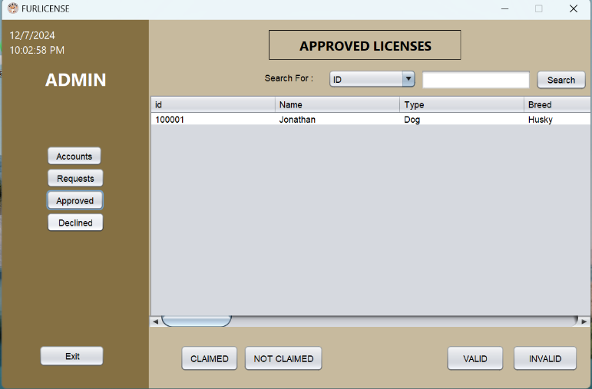

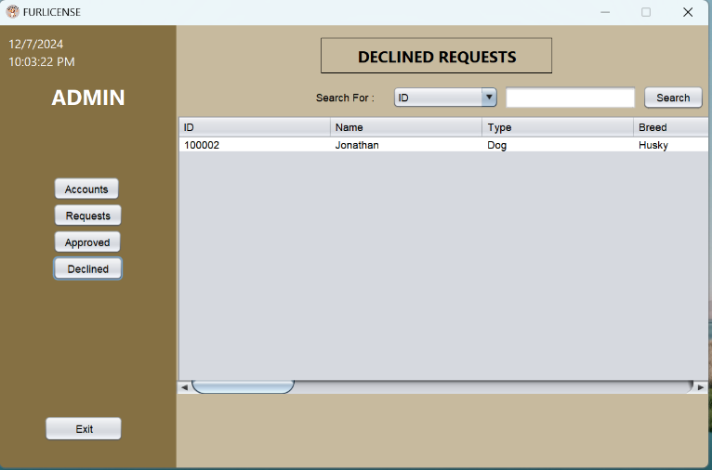

**3. Approved Licenses Interface**: The third interface lists all licenses that have been approved. Once a user'srequest is approved, the license information is automatically displayed in this section. Administrators have the ability to modify the status of a license by forcefully setting its validity to invalid or valid as needed. If a license is marked as invalid, the license will no longer be visible in the user's dashboard. However, if the license is set to valid, the user will once again be able to view it on their dashboard.

**4. Declined Requests Interface**: The fourth and final interface lists all requests that have been declined. In this section, administrators can view the details of each declined request. However, the system does not display the reason for the decline, limiting visibility to basic request information only.

This structured dashboard provides administrators with full control over the registration and renewal processes, allowing them to manage user accounts, review license requests, and maintain license validity as necessary.

**VII. Conclusion**

The system demonstrates a significant step forward in modernizing the pet licensing process through the following key conclusions:

1. **Enhanced Convenience for Users**: The system addresses challenges associated with traditional pet licensing by offering a digital platform that simplifies registration and renewal. This reduces the need for multiple office visits and enhances accessibility, particularly for individuals with busy schedules or mobility constraints.
2. **Efficiency and Streamlining**: By automating processes and providing user-friendly interfaces for both customers and administrators, the system minimizes waiting times and enhances operational efficiency.
3. **Limitations Addressed Transparently**: The system acknowledges certain constraints, such as the lack of support for uploading photos, feedback mechanisms, and notifications for declined requests. While these limitations exist, they do not significantly detract from its primary goal of improving the pet licensing experience.
4. **Step Towards Public Service Modernization**: The system exemplifies the role of technology in enhancing public services. It provides a foundation for future improvements and the potential application of similar solutions to other administrative challenges.

This system effectively showcases the potential of digital tools to streamline processes, with room for future enhancements to broaden its functionality and impact.

**VIII. Recommendation**

The recommendation focus on addressing current limitations and enhancing its overall functionality and user experience. Key recommendations include:

1. **Implement a Notification System**: Introducing notifications for declined requests can improve user communication and reduce uncertainty, providing users with clear updates on their application status.

2. **Enable Photo Upload Features**: Allowing users to upload pet photos and documents directly to the system can streamline the verification process and eliminate the need for physical submissions.

3. **Incorporate Feedback Mechanisms**: Adding a feedback feature would enable users to report issues, suggest improvements, and enhance communication between users and administrators.

4. **Expand System Compatibility**: Extending support to renew licenses not initially registered through the platform could broaden the system’s usability and attract more users.

5. **Enhance Admin Functionality**: Enabling administrators to modify user information or license details could improve system flexibility and accuracy in managing records.

6. **Optimize User Experience**: Refining interfaces for smoother navigation and ensuring accessibility across devices can make the system more user-friendly and inclusive.

By addressing these recommendations, the system can further enhance its efficiency, broaden its scope, and provide an even more comprehensive solution for pet licensing management.